A PROJECT REPORT

on

“**AR Inventory Management System**”

Submitted to

KIIT Deemed to be University

In Partial Fulfilment of the Requirement for the Award of

Bachelor’s Degree In Computer Science & Engineering

BY

Tanmay Prabhu Naidu 1705373

Siddhant Kumar 1705348

Prashast Sharma 1729210

R.L. Adarsh 1705349

UNDER THE GUIDANCE OF

Dr. Aleena Swetapadma



SCHOOL OF COMPUTER ENGINEERING

KALINGA INSTITUTE OF INDUSTRIAL TECHNOLOGY

BHUBANESWAR, ODISHA -751024

November 2020

KIIT Deemed to be University

School of Computer Engineering

Bhubaneswar, ODISHA 751024



CERTIFICATE

This is certify that the project entitled

“**AR Inventory Management System**“

submitted by

Siddhant Kumar 1705348

Tanmay Prabhu Naidu 1705373

Prashast Sharma 1729210

R.L. Adarsh 1705349

is a record of bonafide work carried out by them, in the partial fulfilment of the requirement for the award of Degree of Bachelor of Engineering (Computer Science & Engineering) at KIIT Deemed to be university, Bhubaneswar. This work is done during the year 2019-2020, under our guidance.

Date: / /

Dr. Aleena Swetapadma

Project Guide

**Acknowledgements**

We are profoundly grateful to Dr. Aleena Swetapadma for his expert guidance and continuous encouragement throughout to see that this project rights its target since its commencement to its completion.

Siddhant Kumar

Tanmay Prabhu Naidu

R.L. Adarsh

Prashast Sharma

**ABSTRACT**

While searching for various project ideas, our team decided to focus our attention on our very own college itself. We aimed to develop a product which would not only help our college students with their day to day work but also useful for businesses and an individual in general, while making sure we stay eco-friendly to help reduce the carbon footprint.

After a thorough research and survey around our campus, we realised that there was a need for students to be able to identify machinery/ electronic equipment in case they forget the functions explained by the teacher. One good example of this is the BMS Lab equipment with many moving parts and a need of proper labelling on them. This gave way to the idea of our major project, Object Scanning and Labelling using Augmented Reality. Through this, we were confident to be able to successfully scan and label not only the labs with extensive information attached to the machinery, but it was also useful for businesses looking for inventory management. All through this, our project would be an app, utilising the phone camera and reducing the use of paper in inventory management.

**Keywords:** AR, android, inventory, augmented images, arcore, augmented reality, google, tags, captions, frames, layouts, database, camera, nodes, sceneview, ar fragment,

Contents

|  |  |  |  |
| --- | --- | --- | --- |
| 1 | Introduction | | 1 |
|  | 1.1 | Introduction |  |
|  | 1.2 | Analysis |  |
|  | 1.3 | Ideation |  |
| 2 | Literature Survey | | 2 |
| 3 | Software Requirements Specification | | 3 |
| 4 | Requirement Analysis | | 6 |
|  | 4.1 | Functional Requirements |  |
|  | 4.2 | External Requirements |  |
|  | 4.2 | Non Functional Requirements |  |
| 5 | System Design | | 7 |
|  | 5.1 | System Overview | 6 |
|  | 5.2 | Design Constraints |  |
|  | 5.3 | System Architecture |  |
| 6 | System Testing | | 13 |
| 7 | Project Planning | | 14 |
| 8 | Implementation | | 16 |
|  | 8.1 | DeviceARFragment.kt |  |
|  | 8.2 | DeviceActivity.kt |  |
|  | 8.3 | Device_lot_layout.xml |  |
|  | 8.4 | Device_label_layout.xml |  |
|  | 8.5 | Device_database.imgdb-imglist.txt |  |
|  | 8.6 | Colors.xml |  |
|  | 8.7 | Styles.xml |  |
|  | 8.8 | AndroidManifest.ml |  |
| 9 | Screenshots of Project | | 24 |
|  | 9.1 | User Instruction |  |
|  | 9.2 | Label on a real life object |  |
|  | 9.3 | Multiple labels |  |
| 10 | Conclusion and Future Scope | | 27 |
|  | 10.1 | Conclusion |  |
| 10.2 Future Scope | | |  |
| 11 References | | | 28 |

List of Figures

|  |  |  |
| --- | --- | --- |
| 1 | ARIMS Project Outline | 8 |
| 2 | ARIMS App Outline | 9 |
| 3 | ARIMS Class Diagram | 10 |
| 4 | ARIMS Use Case | 11 |
| 5 | ARIMS Sequence Diagram | 12 |
| 6 | Instruction Layout | 24 |
| 7 | Label on a real life object (A) | 25 |
| 8 | Label on a real life object (B) | 25 |
| 9 | Multiple Labels on real life objects (A) | 26 |
| 10 | Multiple Labels on real life objects (B) | 26 |

Chapter 1

Introduction

1.1 Introduction

While searching for various project ideas, our team decided to focus our attention on our very own college itself. We aimed to develop a product which would not only help our college students with their day to day work but also useful for businesses and an individual in general, while making sure we stay eco-friendly to help reduce the carbon footprint.

1.1 Analysis

After a thorough research and survey around our campus, we realised that there was a need for students to be able to identify machinery/ electronic equipment in case they forget the functions explained by the teacher. One good example of this is the BMS Lab equipment with many moving parts and a need of proper labelling on them. This gave way to the idea of our major project, Object Scanning and Labelling using Augmented Reality. Through this, we were confident to be able to successfully scan and label not only the labs with extensive information attached to the machinery, but it was also useful for businesses looking for inventory management. All through this, our project would be an app, utilising the phone camera and reducing the use of paper in inventory management.

1.3 Ideation

We wanted to develop a system for better inventory management and routine safety inspections for large scale machinery used in industries. We want to enable the personnel to effectively understand and document objects on a huge scale. The idea of documenting on an unprecedented level enables the personnel to have more control over machinery and its history or repairs and operation.

Chapter 2

Literature Survey

Before getting hands on with the project. Our team understood the need to fully comprehend Augmented Reality, Android and how we should go about developing a working solution.

a) Our team started with learning about augmented reality and how it can aid us to develop a solution.

We first decided to understand if our solution was **validated** or not. News sources and statistics from the sites similar to the one mentioned below helped us validate our project idea.

([Pick-by-Vision with Augmented Reality to Solve the Problem of Inaccurate Inventory in the Warehouse](https://medium.com/@info_35021/pick-by-vision-with-augmented-reality-to-solve-the-problem-of-inaccurate-inventory-in-the-warehouse-c4b79a1f57e5)).

b) Once validated. We went ahead in understanding how augmented reality could help us solve the afore mentioned problem. Our team consulted every resource available from detailed articles to inspiring Youtube videos. Examples of such resources are mentioned below:

([Leveraging Augmented Reality for Warehouse Management](https://www.scandit.com/blog/leveraging-augmented-reality-for-warehouse-management/))

([Logistics 4.0 – Augmented Reality use cases](https://www.youtube.com/watch?v=3YqaRrzkM4c))

c) After gaining valuable information and inspiration from the resources, our team moved on to finding a platform to build our AR project on. It was decided, due to the robustness and connectivity of Google’s AR platform with Android, that we would go with the same.

([Google’s Augmented Reality Site](https://arvr.google.com/ar/))

d) We then found out that Google’s AR platform is known as **ARCore**. The team spent some time familiarising with the different aspects of the site.

([Google’s ARCore Site](https://developers.google.com/ar))

e) On diving deeper into the platform. Our team spent days familiarising ourselves with the various features, compatibility aspects, supported devices, scope of the platform.

([ARCore’s Supported Devices](https://developers.google.com/ar/discover/supported-devices))

f) After understanding ARCore, our team downloaded the same from google play store.

([Google ARCore](https://play.google.com/store/apps/details?id=com.google.ar.core&hl=en_IN))

g) To get hands on with the project. We used Android Studio hand in hand with ARCore.

([Google Android](https://developer.android.com/))

Our team did not stop consulting resources and literature when we were doing the project. We made excessive use of the coding repositories and communities to gather more information about how we could polish our project further.

([Android Github](https://github.com/topics/android-app))

Chapter 3

Software Requirements Specification

1. **Introduction**

The project would be made for the android platform using Android Studio, Google ArCore and work would be distributed accordingly between team members to finish and compile together to fulfil the project.

2. **Purpose**

The purpose of the project is to develop an app which is able to display stored information about an object/image when it is scanned in a well-lit environment.

3. **Intended Audience**

The app is targeted towards students needing help to interactively label equipment for future reference and also towards industries needing a way to manage inventory.

4. **Scope**

This project’s scope consists of all android devices used by students and corporate workers. It also covers any individual using an android device. The app promises to scan any image/ object and allow the user to add, store and edit the labels on it.

5. **Overall Description**

It allows users to mark objects in the real world and give them a description in a window that floats above the real world object.

6. **User Needs**

1. An Android Device running android version 7 or higher.
2. Device should come preinstalled with the Google Play Store.
3. Device should support and be able to download Google Play Services for AR from the Google Play Store.
4. A functioning Camera.
5. Knowledge of scanning and interacting with AR apps.

7. **Assumptions and Dependencies**

1. Scanned object must already be registered in the database.
2. There should be a brightly lit environment.

8. **System Features and Requirements**

Features:

1. Scanning any object/image
2. Remembering the scanned image/object
3. Ability to add labels to the scanned object/image
4. Ability to edit labels as per requirements.
5. Ability to add multiple labels.
6. Ability to delete multiple labels.
7. Ability to interact with the objects using the app after storing the information about it.

Requirements:

1. Functional Requirements: App should display relevant information about scanned objects in real time. It should track the object independent of the user's position and orientation.
2. External Interface Requirements: App should be able to communicate with external server to reference the image database.
3. Non-Functional Requirements: App should be able to refer database and show relevant information in real time. App should be easy to use for inexperienced people. App should be able to scan objects and machinery of any size and be able to be used in warehouses and the field.

Chapter 4

Requirement Analysis

4.1 Functional Requirements

* App should display relevant information about scanned objects in real time.
* It should track the object independent of the user's position and orientation.
* Modify labels as per requirements.
* Delete labels as per requirements.
* Remember the localized position of the scanned object.

4.2 External Requirements

* App should be able to communicate with an external server to reference the image database.
* Communicate with other nearby devices for compiling better tracking data.

4.3 Non Functional Requirements

* App should be able to show relevant information in real time.
* App should be easy to use for inexperienced people.
* App should be able to scan objects and machinery of any size and be able to be used in warehouses and the field.
* App should be able to accurately display information on the scanned object.

Chapter 5

System Design

5.1 System Overview

We wanted to develop a system for better inventory management and routine safety inspections for large scale machinery used in industries. We want to enable the personnel to effectively understand and document objects on a huge scale. The idea of documenting on an unprecedented level enables the personnel to have more control over machinery and its history or repairs and operation.

5.2 Design Constraints

User must understand what AR is.

User must be connected to an internal network.

Working area must be brightly lit.

Database images must be high quality for faster recognition.

Tracker images on physical objects should be clear.

5.3 System Architecture

5.3.1 Project Outline

Macro view of flow of data between components of the project.

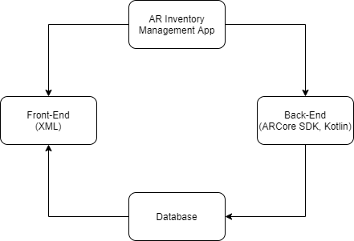

AR Inventory Management System Outline

5.3.2 App Outline

The app outline gives us an illustration of the flow of control in the app.

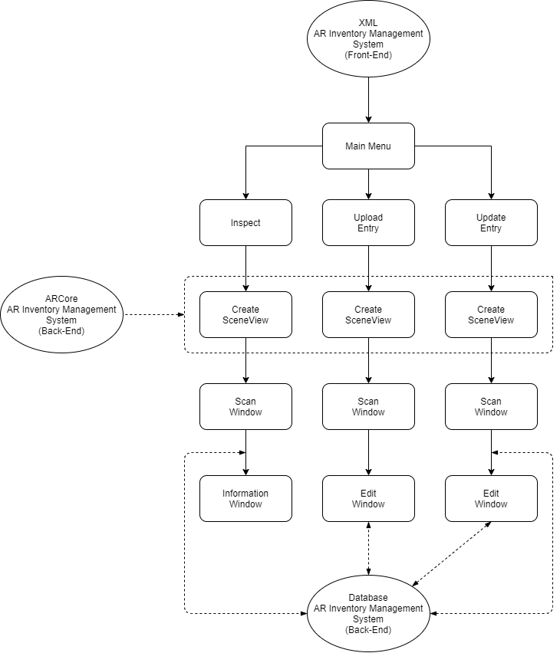

Application Outline

5.3.3 Class Diagram

A class diagram is a visual representation of the relationships and source code dependencies among classes in the unified modelling language.

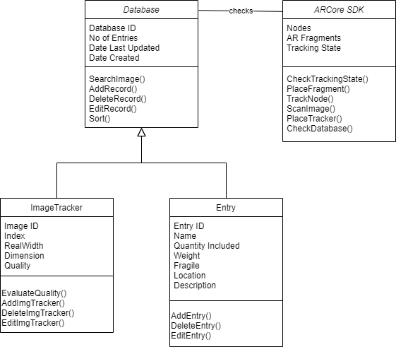

Class Diagram

5.3.4 Use Case

A use case diagram is a graphical representation of the interaction of different users with the system.

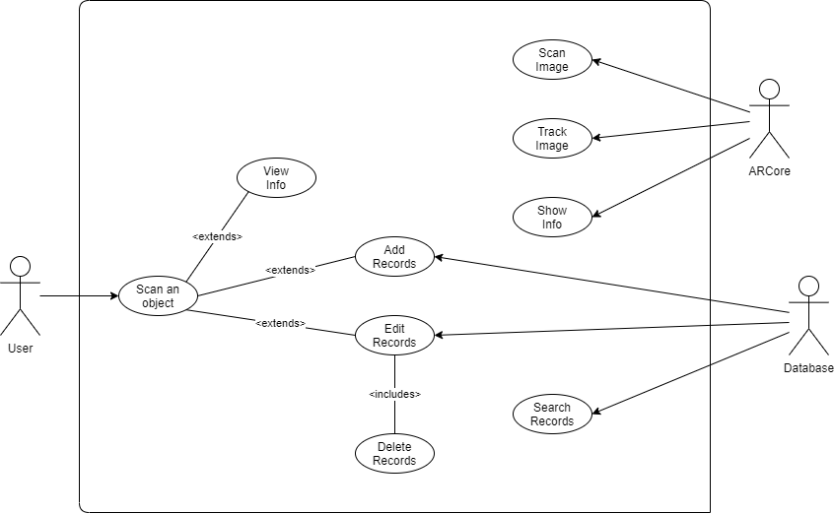

Use Case Diagram

5.3.5 Sequence Diagram

It shows the objects and classes involved in the scenario and the sequence of messages exchanged between the objects/classes needed to carry out the functional requirements. This diagram shows the sequence for the flow of data between components for the view info use case.

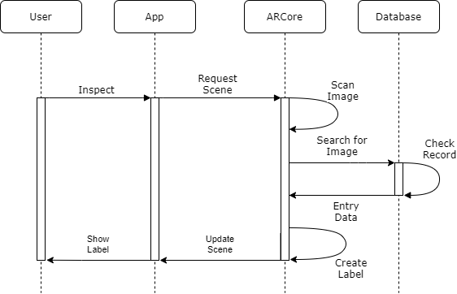

Sequence Diagram for view info use case.

Chapter 6

System Testing

The system testing was performed in a brightly lit room. The image database was populated with high quality scans of the object. The objects used were phone boxes from different manufacturers which showed a specification sheet for the model in the frame

6.1 Test Cases and Test Results

|  |  |  |  |  |
| --- | --- | --- | --- | --- |
| Test | Test Case Title | Test Condition | System Behavior | Expected Result |
| ID |  |  |  |  |
|  |  |  |  |  |
| T01 | Scanning Image | Point camera at tracker image | Shows window floating over object with information | Should show window floating over object with information |
|  |  |  |  |  |
| T02 | Adding Record | Scan new tracker and enter new information for it | New information is uploaded to database | Should reflect new information in database and on subsequent inspections |
|  |  |  |  |  |
| T03 | Editing Record | Scan existing tracker and enter updated information for it | Edited information is uploaded to the database | Should reflect edited information in database and on subsequent inspections |
|  |  |  |  |  |
| T04 | Scanning multiple images | Point camera in such a way so that multiple images are in view | Shows window floating over all recognisable objects with each’s information | Should show window floating over all recognisable objects with each’s information |



Chapter 7

Project Planning

7.1 Scope planning

We plan to implement the functionality to view information about real world objects in a floating window hovering above it. The user can add new labels of information to more objects and modify them in the app.

7.2 Resource planning

Prashast Sharma- Coder, Tester

Tanmay Naidu- Coder, Tester

Siddhant Kumar- Tester, Documenter

R. L. Adarsh- Tester, Documenter

7.3 Budget planning

We are currently working for our college project with a team of students which evidently doesn’t require any monetary expenditure whatsoever.

7.4 Procurement planning

For coding the project we need workstations with ample performance to compile the apps. We also need an active internet connection to sync the project with gradle. We can use our university provided and personal computers as the workstations with our personal mobile data and home internet connection for syncing.

For testing the project we need android phones with at least the minimum required specs and some dummy objects to test on. We can use our personal phones and their retail boxes for testing.

7.5 Risk management

If any errors or unwanted circumstances are encountered by our users, we’ll be training the IT staff of the client company so they can troubleshoot any errors that might arise. This ensures that the errors are swiftly handled within the company itself and avoid 3rd party interventions.

7.6 Quality planning

Various factors can govern the quality of our project such as the algorithms itself. Presently we are implementing a simple database file for images which is included in the app itself. We plan to implement an external server so that multiple people can access the same shared data.

With respect to GUI, we are planning to implement an easier layout for technologically inexperienced users.

7.7 Communication planning

For communication between team members we used GitHub for managing the code and meetings were held every fortnight over discord for ensuring that the team stays in line with the goals.

Chapter 8

Implementation

Implementation refers to the process of converting the system architecture into individual modules and then finally integrating them keeping in mind that all the functional and non-functional requirements are met. The implementation can be subdivided into-

* Getting models in the scene
* Having models anchor on a real world object
* Referencing the image database for any hits on the screen
* Displaying the information on the label for the user

8.1 DeviceARFragment.kt

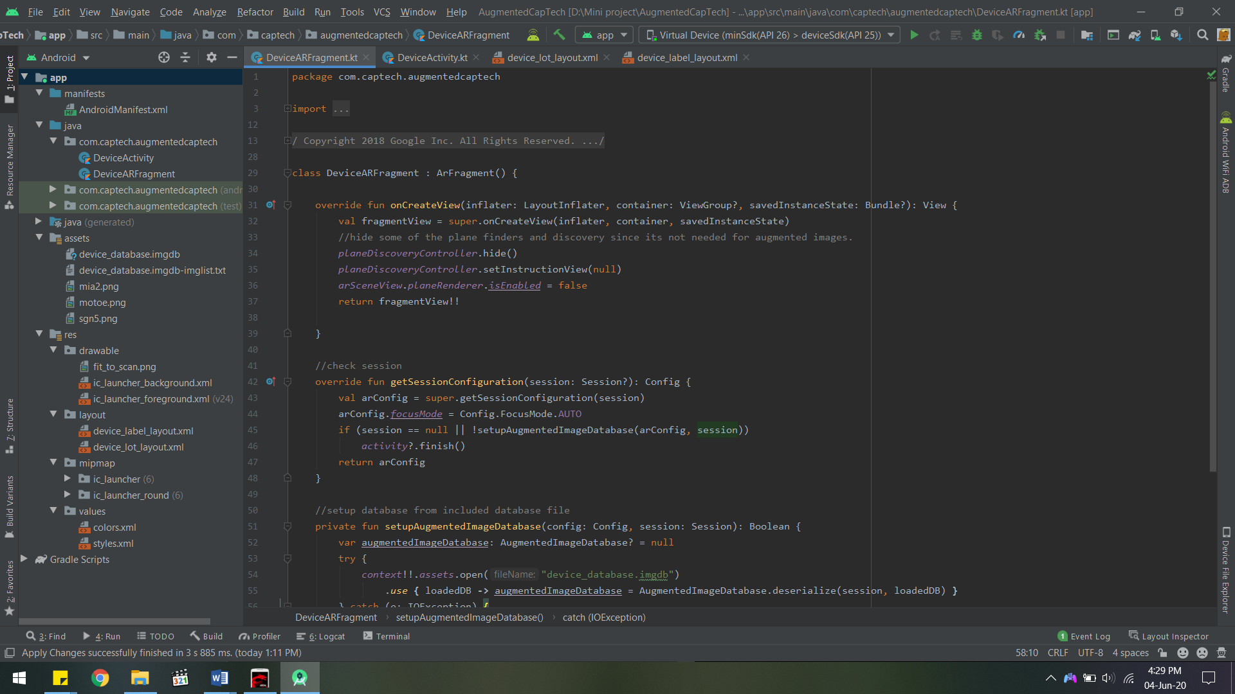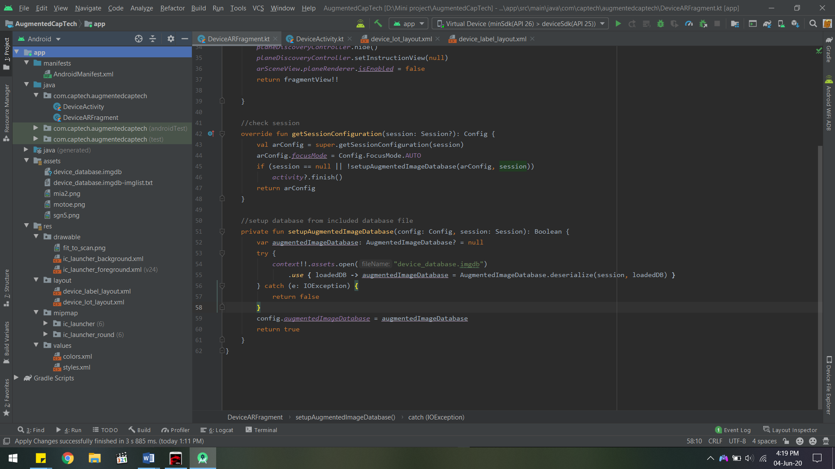

onCreateView() is used to initialise the view for doing graphics on the main view. We also disable the default plane finding functionality as we will be tracking specific images instead.

getSessionConfiguration() is used to get the current sessions properties and set auto focus. If a session is not found then the activity is closed.

setupAugmentedImageDatabase() is used to initialise the database with the included database file in the app.

8.2 DeviceActivity.kt

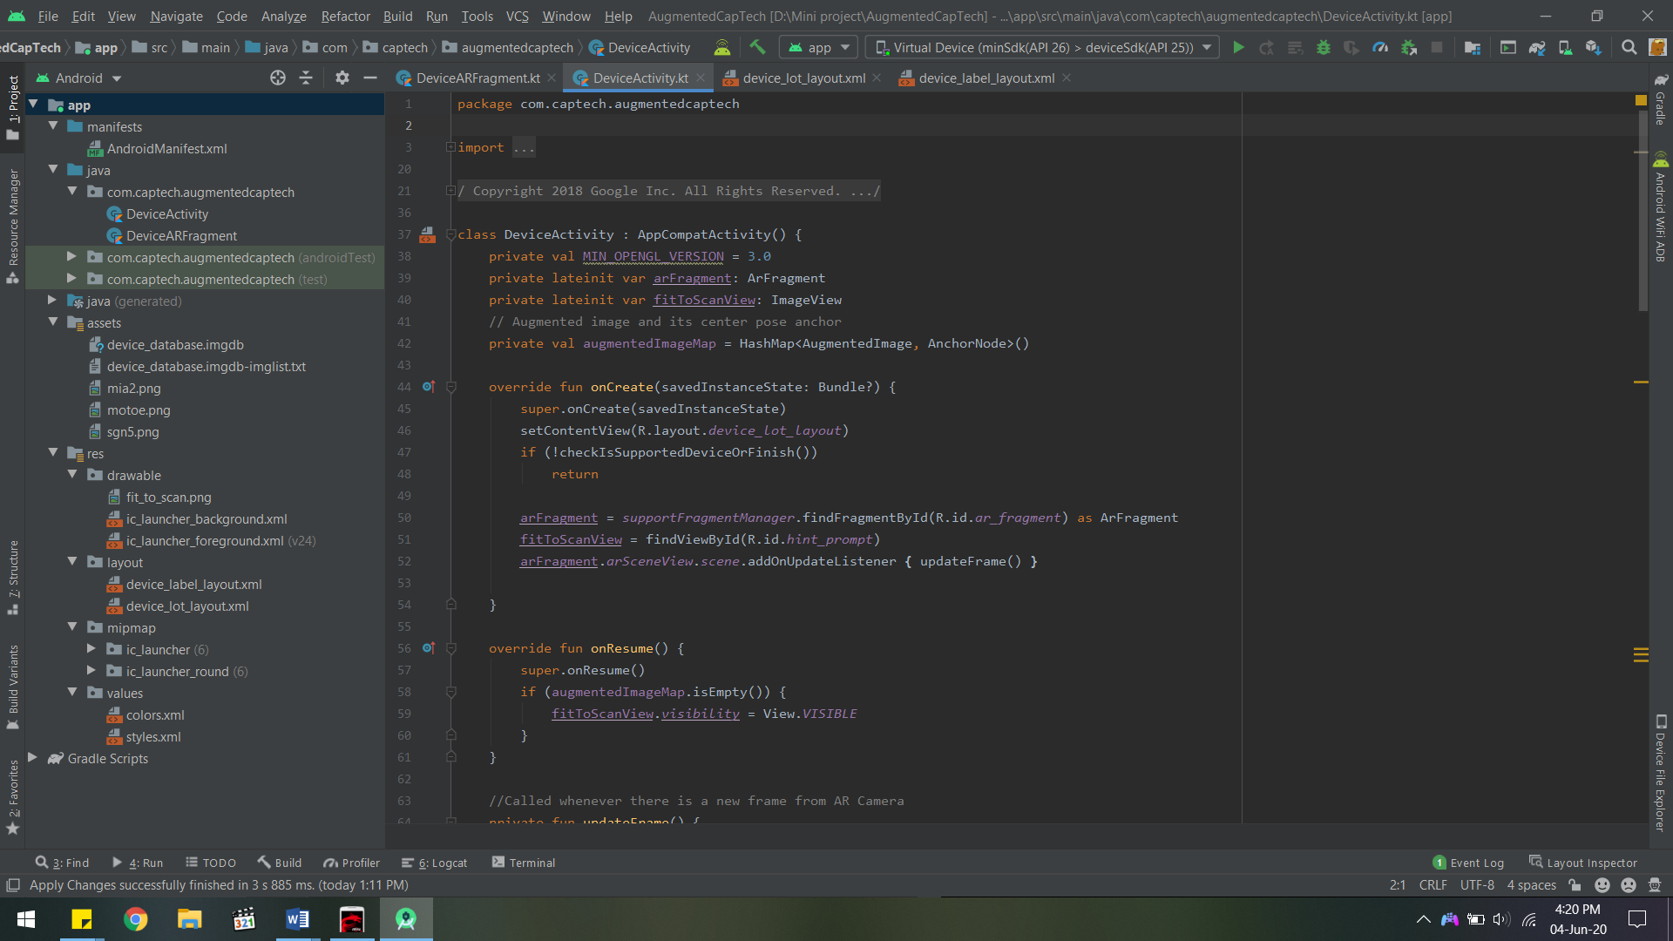

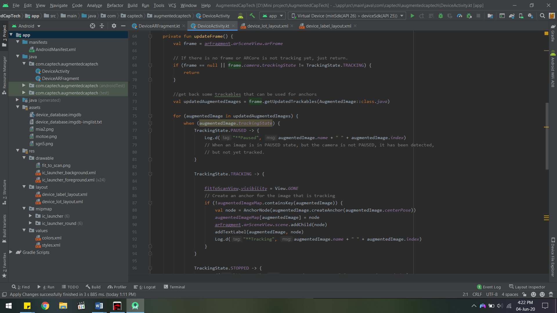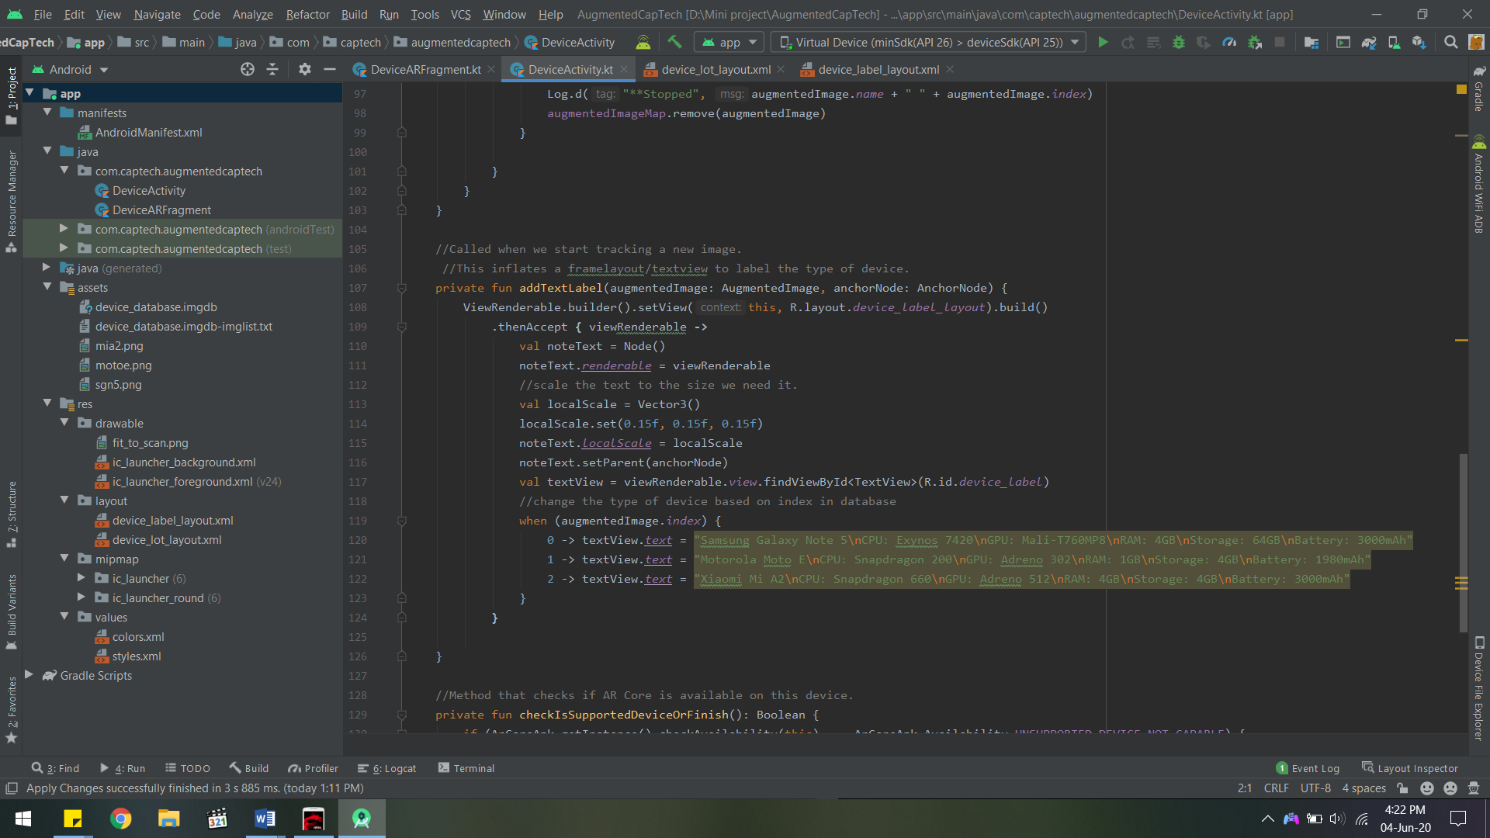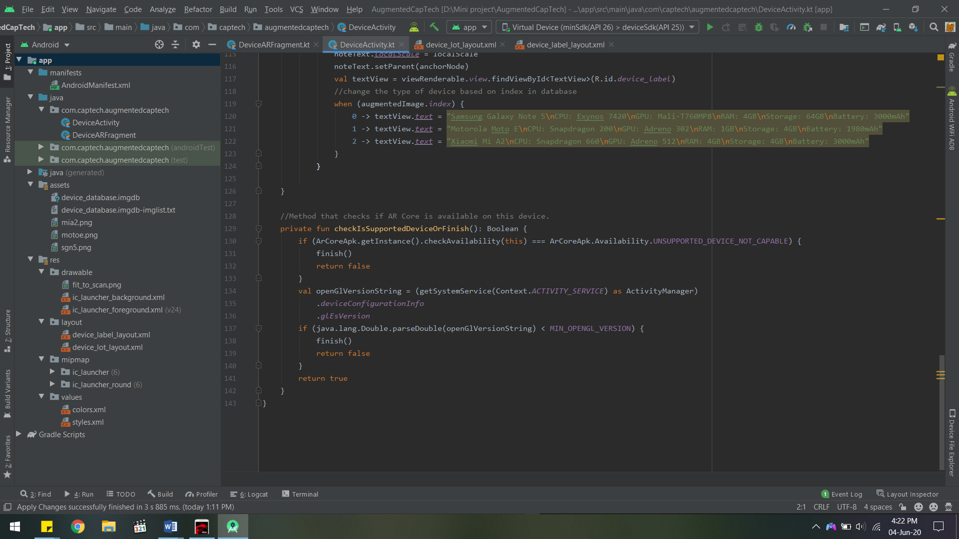

onCreate() is used to start and initialise the main activity.

onResume() is used to resume the activity when the image is visible again.

updateFrame() is called whenever there is a new frame from AR Camera. It checks if there is no frame or ARCore is not tracking yet. It gets back some trackables that can be used for anchors. It also defines what happens in each tracking state. There are 3 states- paused, tracking and stopped. When an image is in paused state, but the camera is not paused, it has been detected, but not yet tracked. When it is in tracking state an anchor is created for the image that is tracking. When it is in stopped state the augmented image is removed.

addTextLabel() is called when it starts tracking a new image. This inflates a framelayout/textview to label the type of real world object. It scales the text shown to a relevant size. It also places the correct information based on the index of the image scanned in the database.

checkIsSupportedDeviceOrFinish() checks if AR Core is available on the current device.

8.3 device_lot_layout.xml

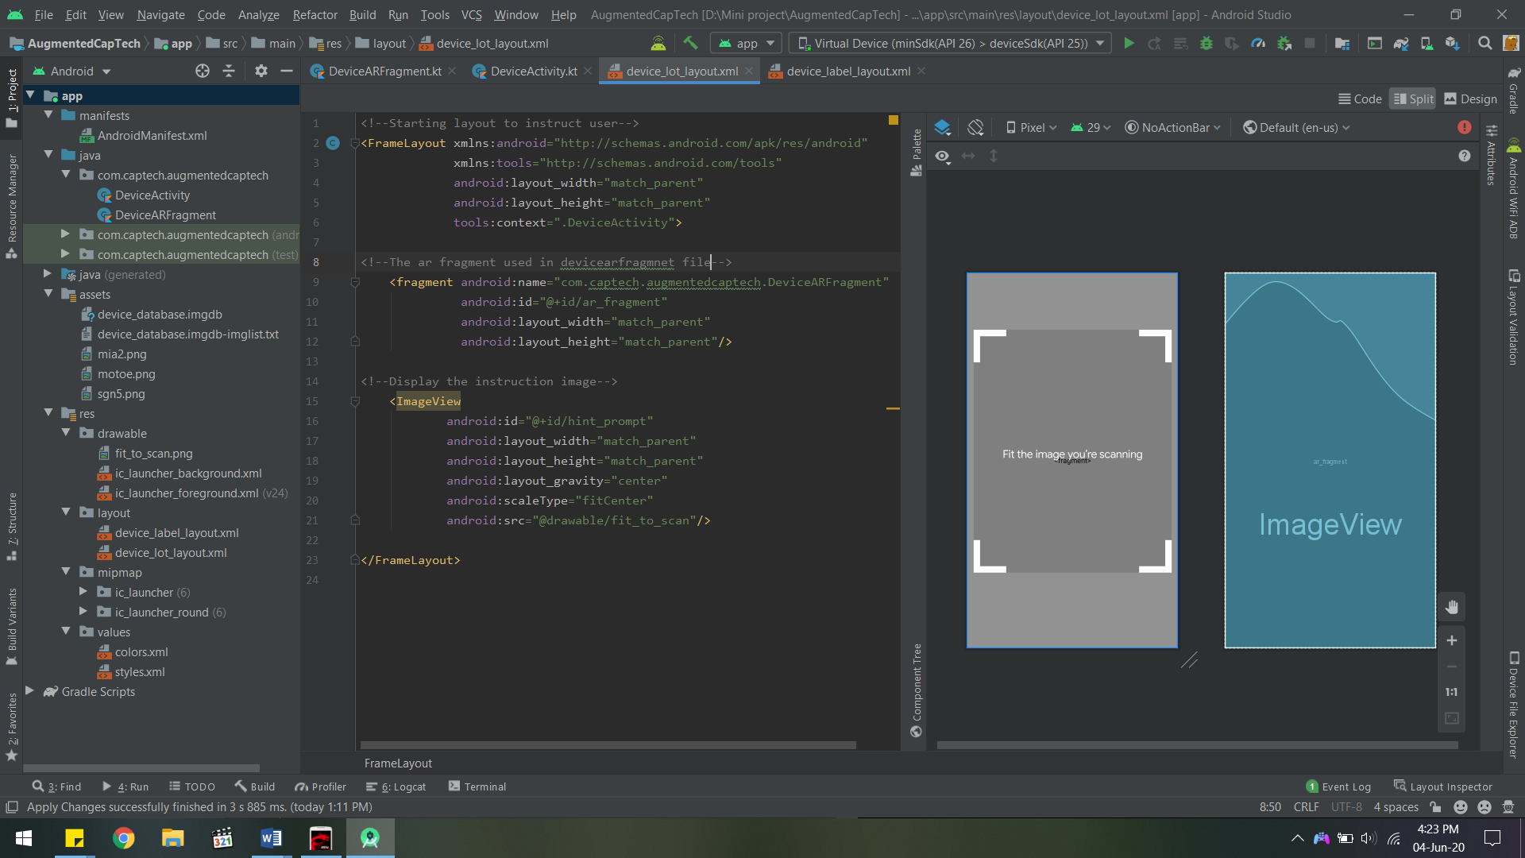

This is the starting layout to instruct the user and contains the arfragment.

<fragment> is used in DeviceARFragment.kt.

<ImageView> is used to display the instruction image over the camera to instruct the user.

8.4 device_label_layout.xml

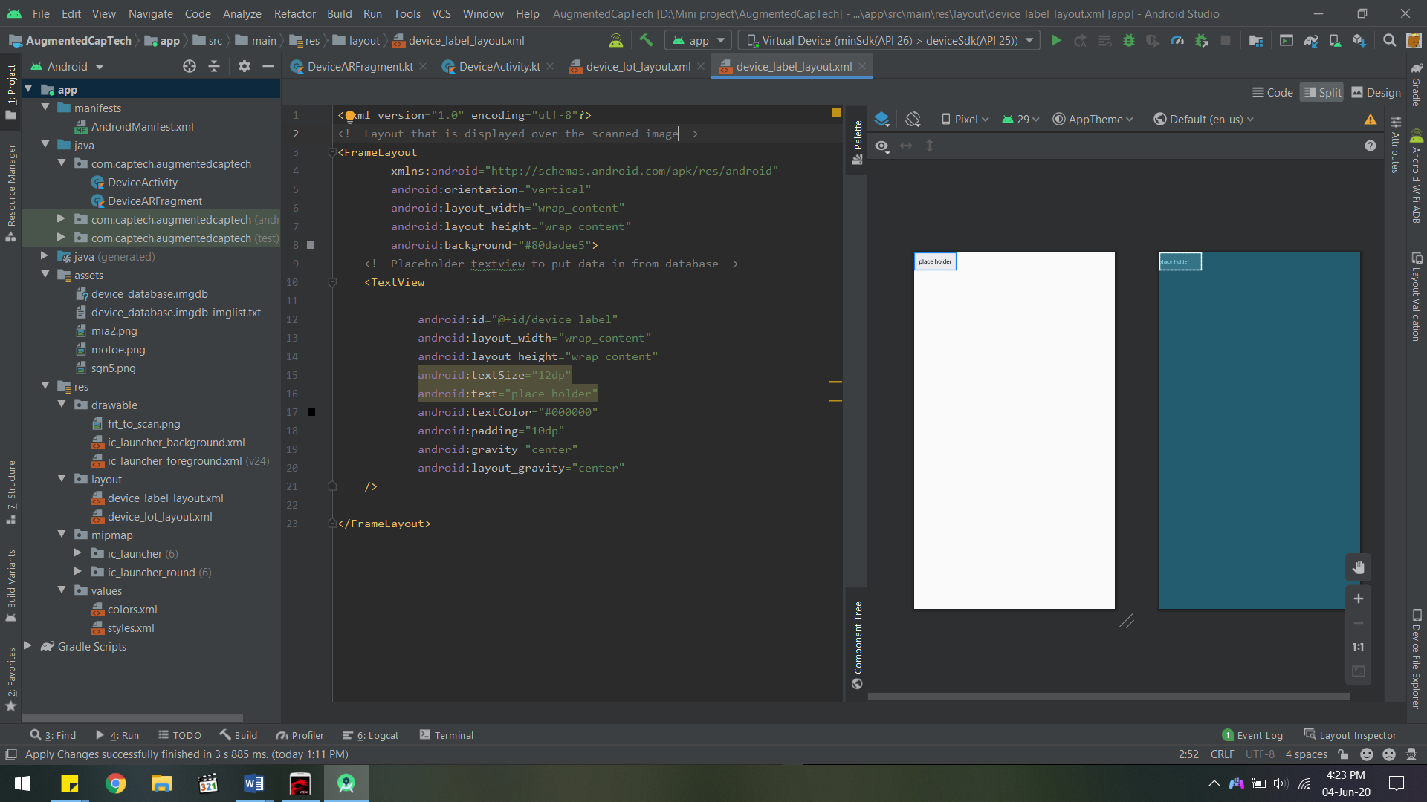

This layout contains the text displayed over the scanned image.

<TextView> is the placeholder to put data into from the database.

8.5 device_database.imgdb-imglist.txt

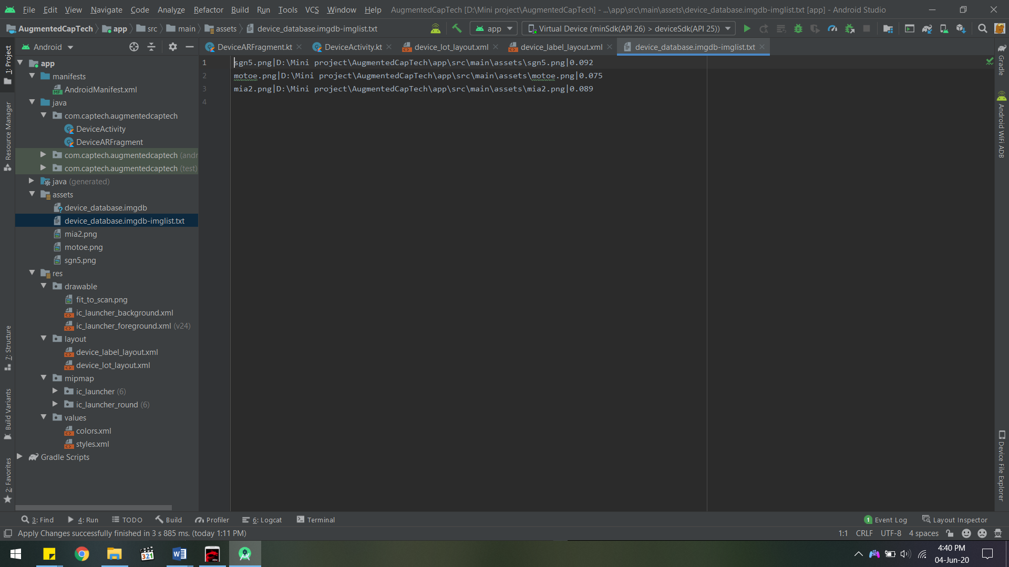

This is the file used to create the database file using the arcoreimg tool included with arcore sdk.

It defines the name of the image, its path and the object’s width in meters.

8.6 colors.xml

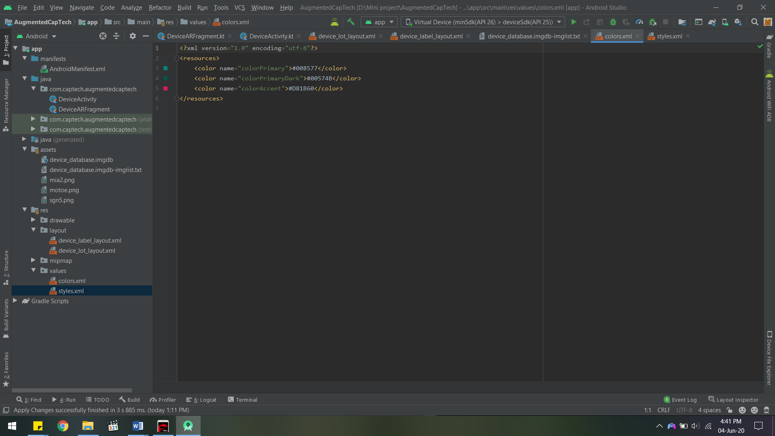

This file defines the colors used in the project. Different parts of the project can use the names defined here instead of defining them separately for each instance.

8.9 styles.xml

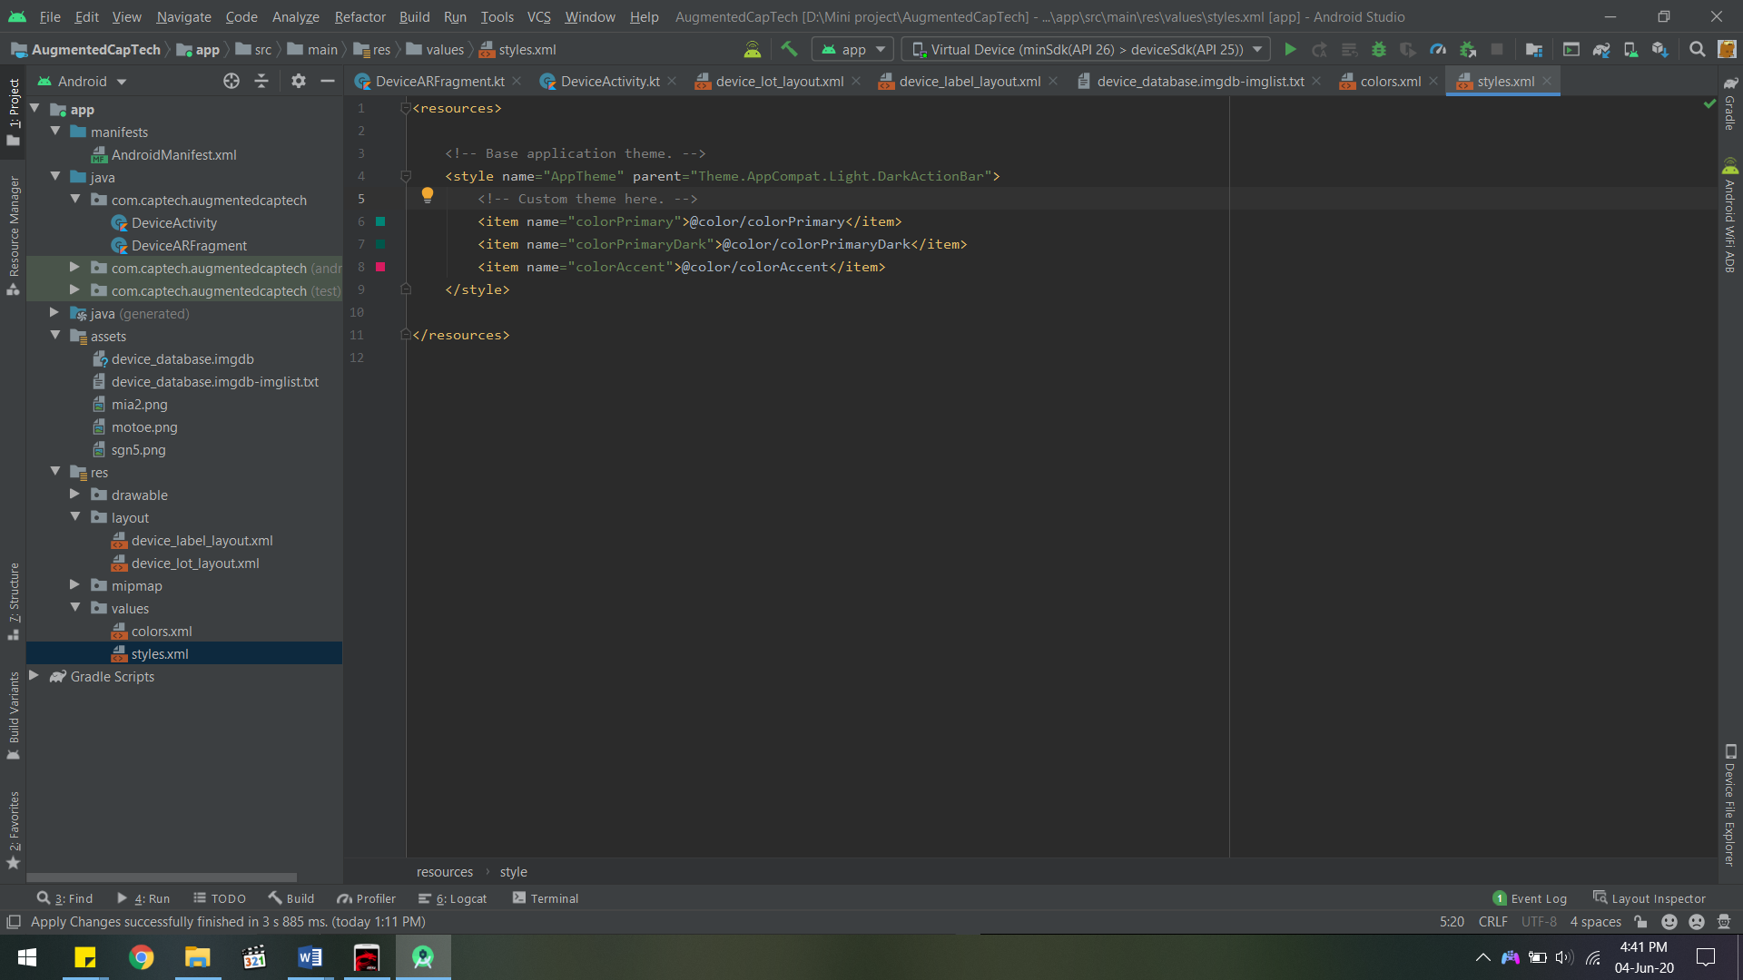

This file is used to define a default theme for the whole app.

8.10 AndroidManifest.xml

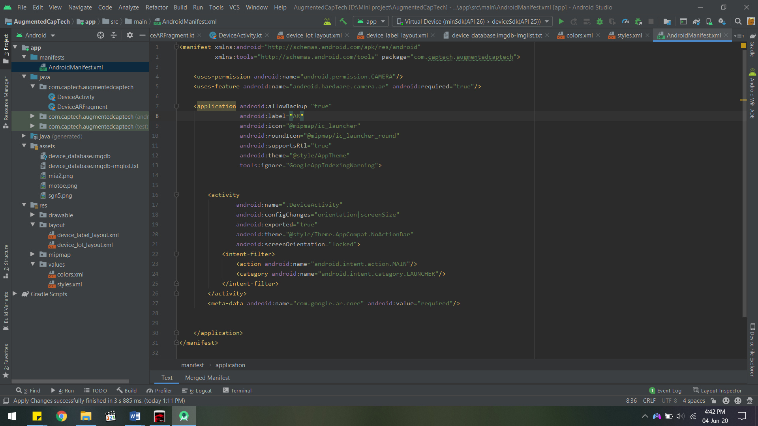

This file is auto generated and contains the basic properties of the app like its name, launcher icon, theme, etc

Chapter 9

Screenshots of Project

9.1 Instruction for user

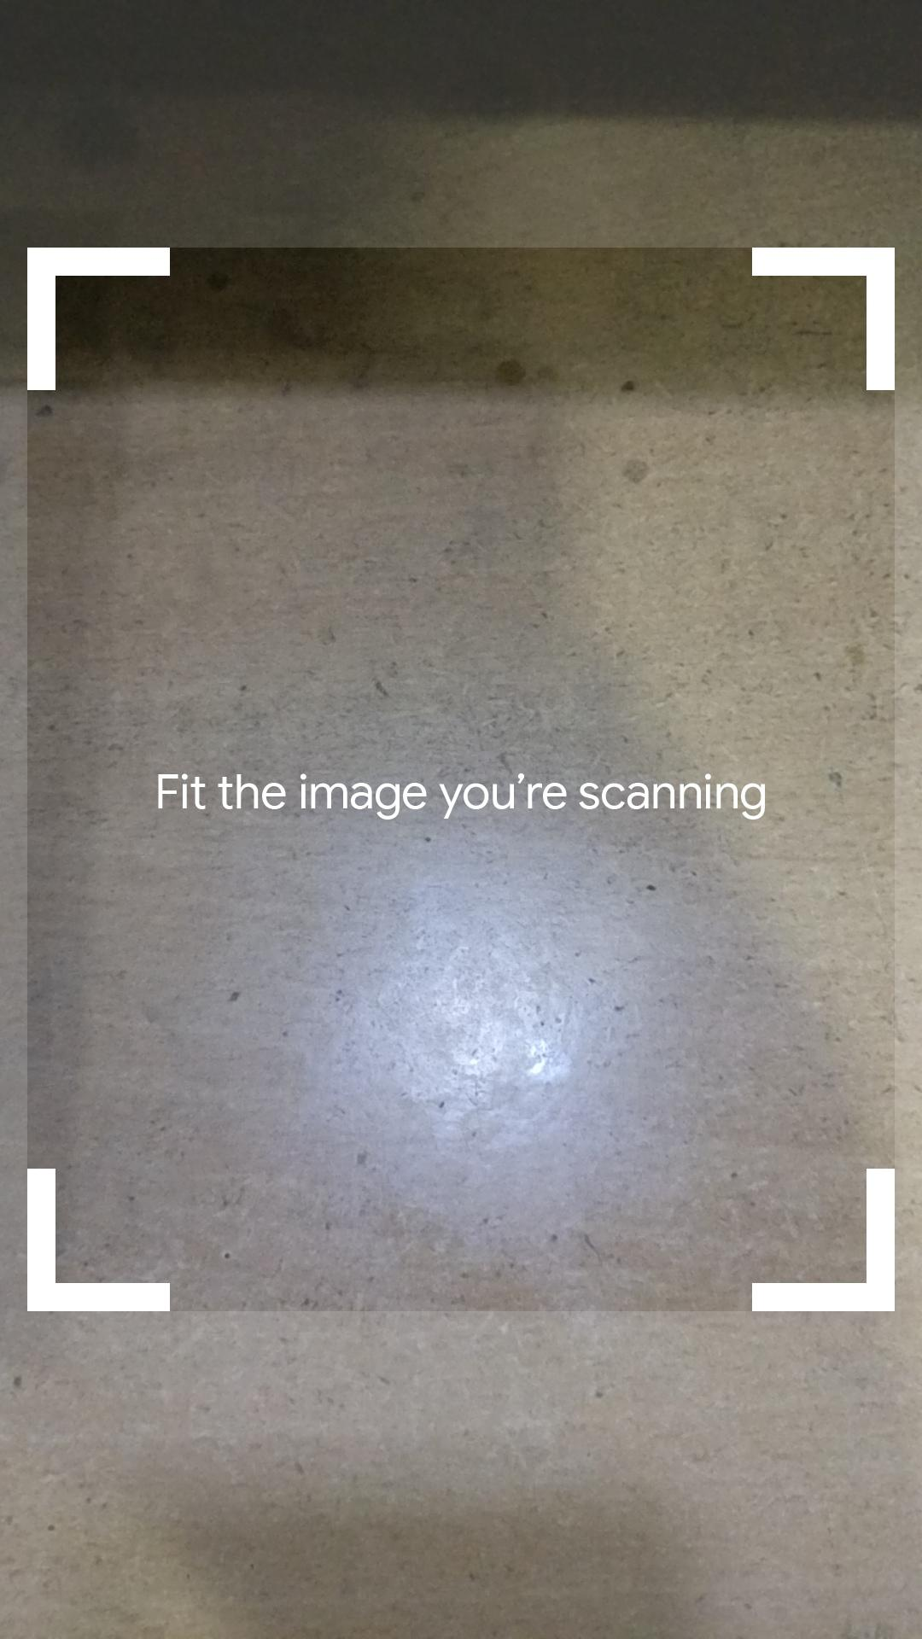

Instruction Layout

9.2 Label with relevant information on a real life object

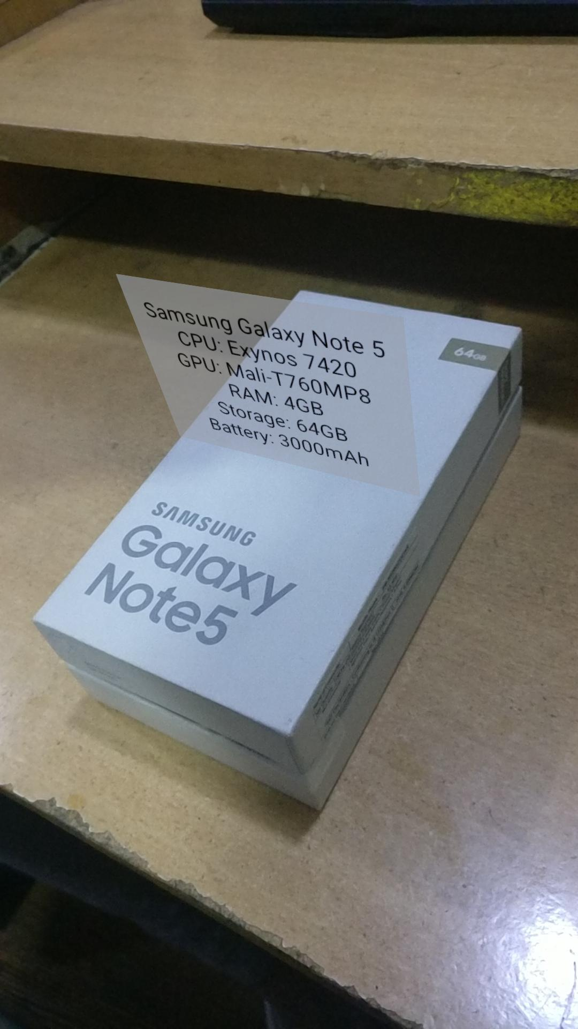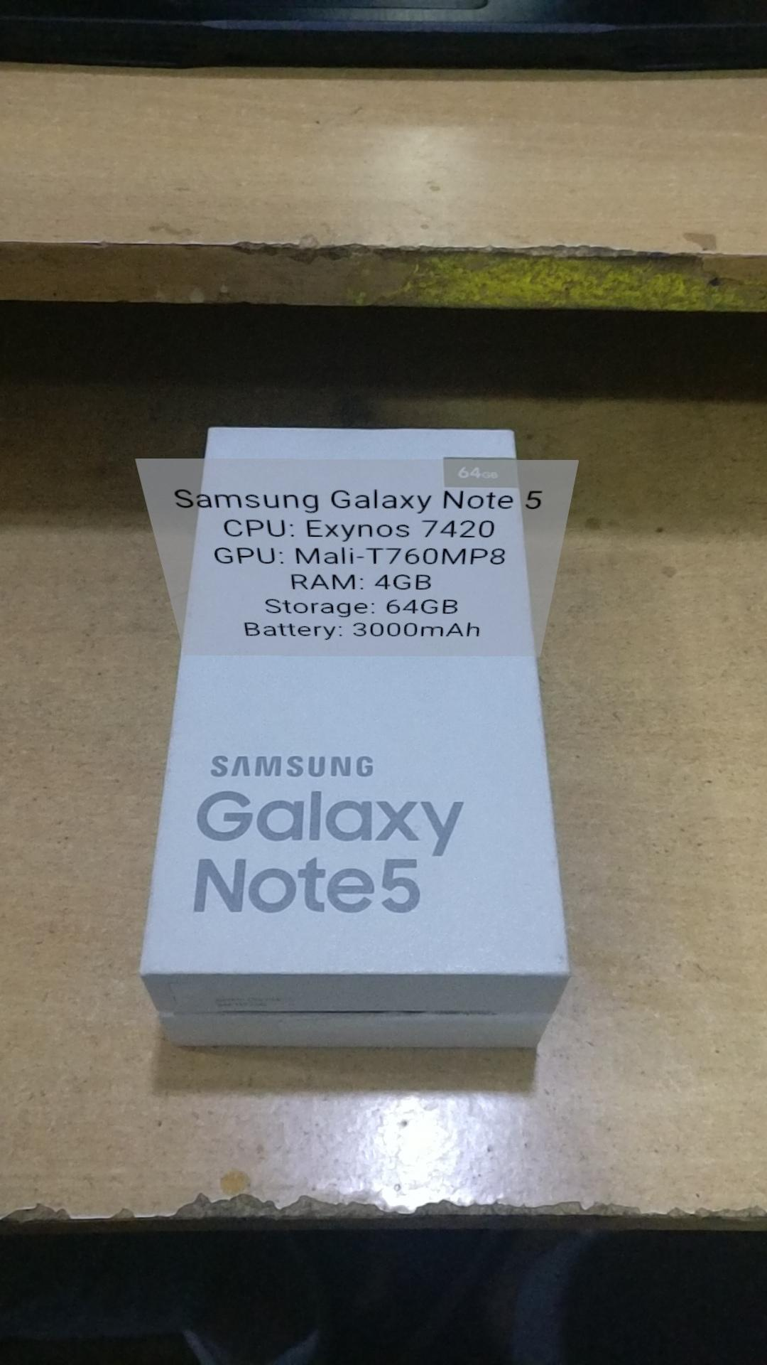

Label on a real life object

9.3 Labels for multiple real life objects at the same time

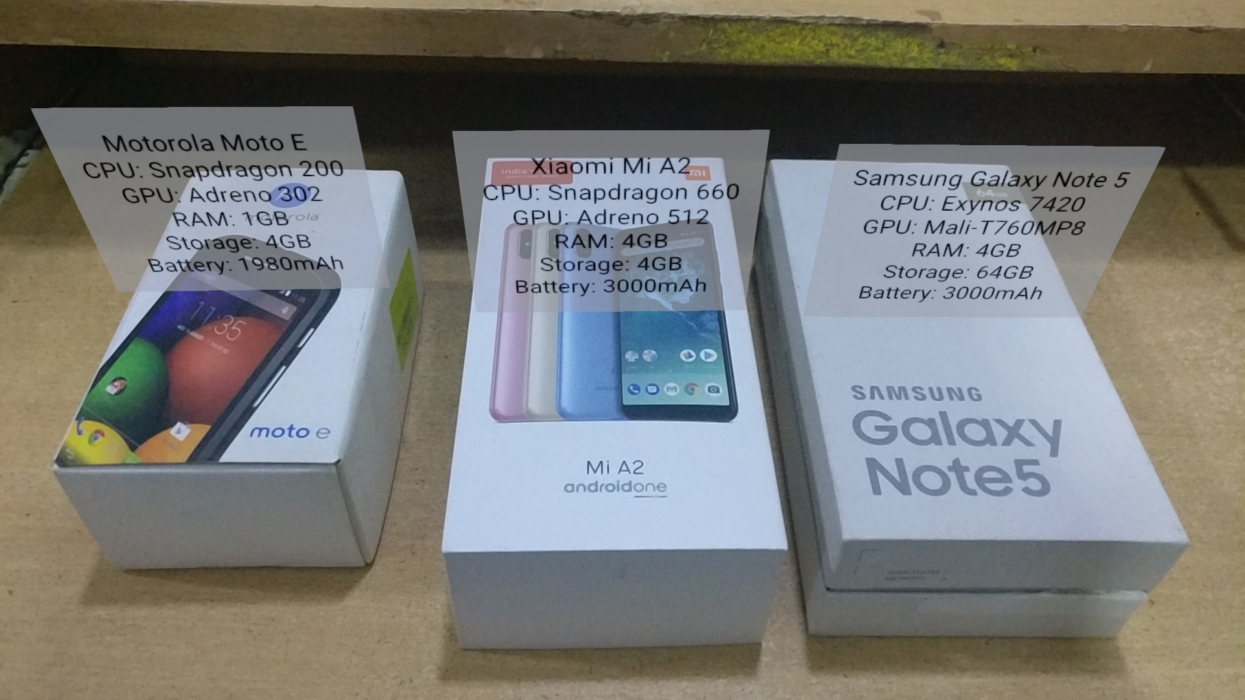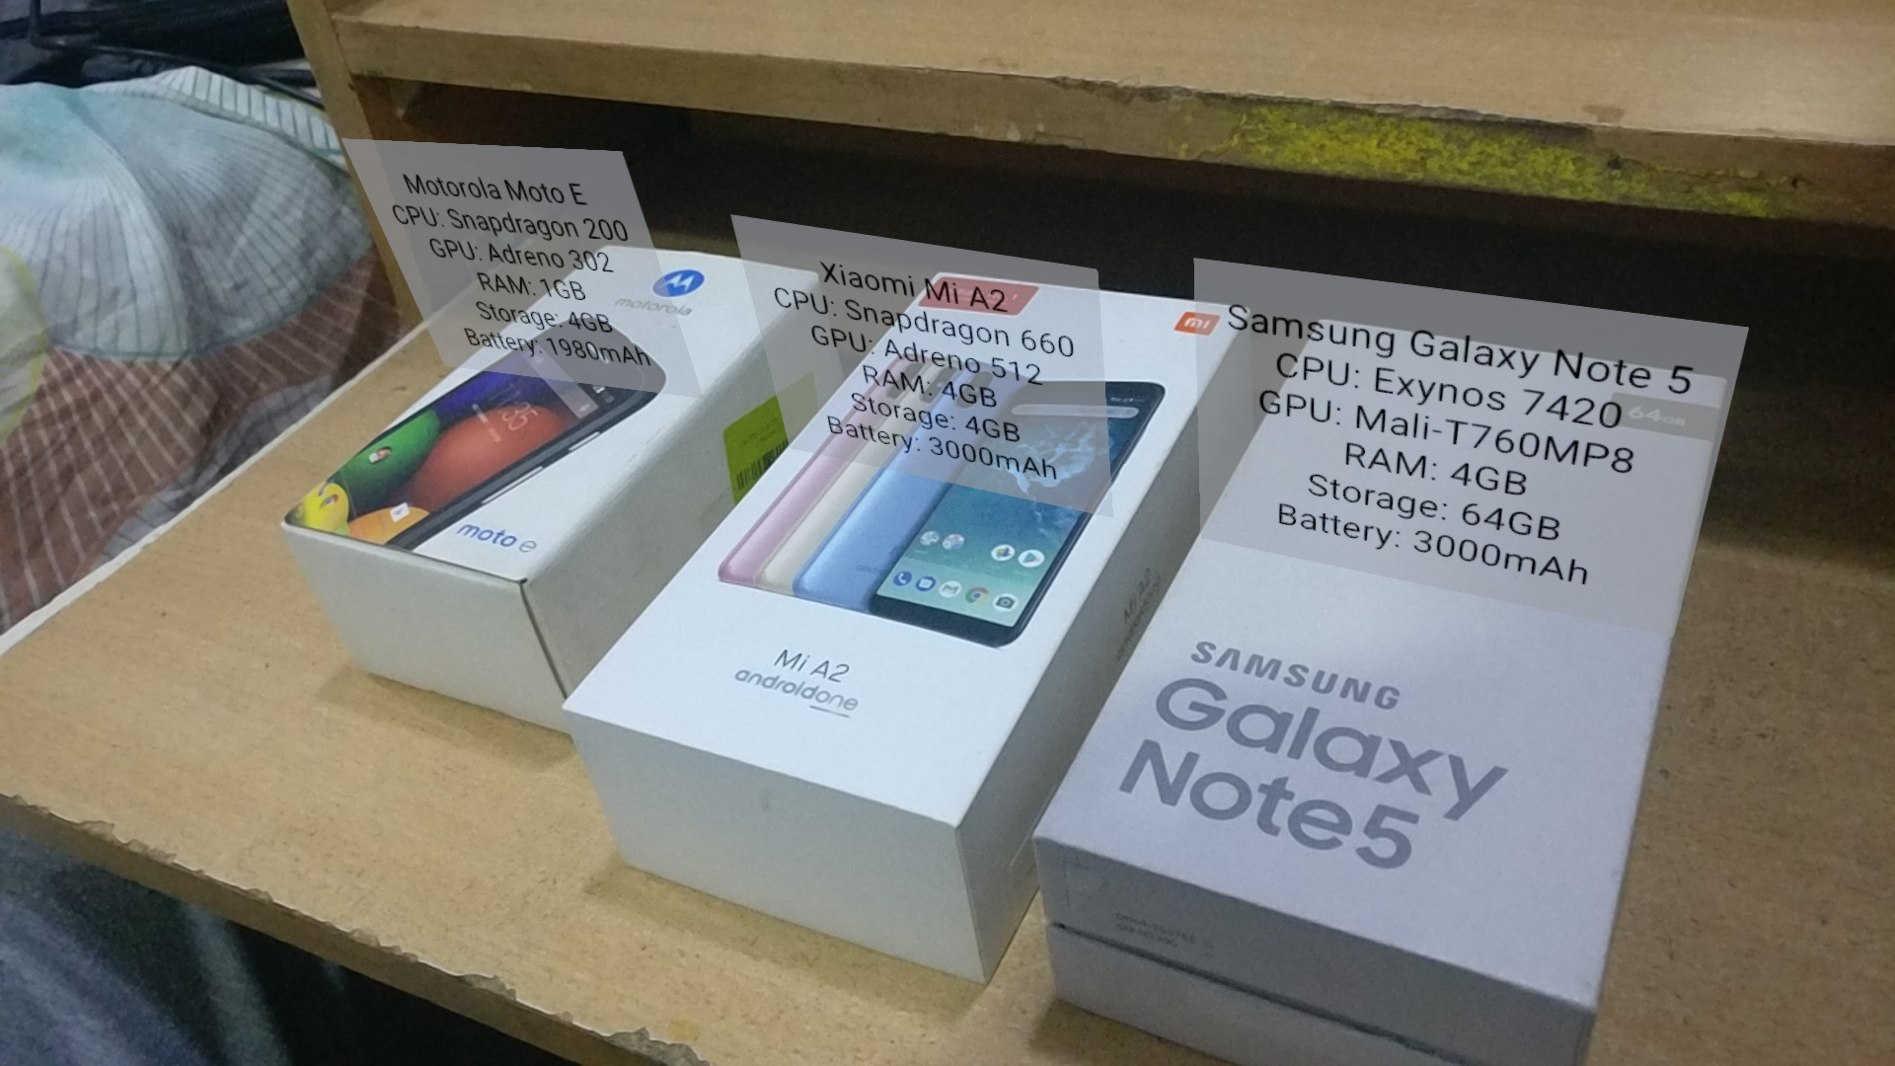



Label on multiple objects

Chapter 10

Conclusion and Future Scope

10.1 Conclusion

With industries rapidly growing larger in scale and shifting their focus to overseas trade, companies now face a new challenge, effectively accounting for and document the immense amounts of goods they have in stock. At the same time, industries have to employ the use of heavy machineries and need to stay on top of maintenance at all times to ensure efficient working of the plant. But taking into account the immense scale of these challenges, whether it be managing millions of goods or finding faults the size of a hair in towering buildings are daunting challenges. We developed an app that enables the personnel to mark goods, document them and store them in a database. They can walk around the premises with their phone and point at any good and instantly get the details of it. On the flip side they can look up any object on the database and immediately get its location on the premise. Similarly for maintaining heavy machinery a repair man can virtually tag the unit at fault quickly as they discover it and also help the future repair men to see a history of the repairs made on a unit.

10.2 Future Scope

In the future, we expect to make the following changes-

* An external server so that multiple users can access the shared data at the same time without updating their app constantly.
* Better functionality and ease of use so that users can drag and drop labels by touching the augmented label on their screens.
* An iPhone version of the app.
* Cross connectivity with other AR Systems like Windows Mixed Reality headsets, Oculus headsets, MagicLeap headsets, etc.

References

[1] Pick-by-Vision with Augmented Reality to Solve the Problem of Inaccurate Inventory in the Warehouse

<https://medium.com/@info_35021/pick-by-vision-with-augmented-reality-to-solve-the-problem-of-inaccurate-inventory-in-the-warehouse-c4b79a1f57e5>

[2] Leveraging Augmented Reality for Warehouse Management

<https://www.scandit.com/blog/leveraging-augmented-reality-for-warehouse-management/>

[3] Logistics 4.0 – Augmented Reality use cases

<https://www.youtube.com/watch?v=3YqaRrzkM4c>

[4] Google’s Augmented Reality Site

<https://arvr.google.com/ar/>

[5] Google’s ARCore Site

<https://developers.google.com/ar>

[6] ARCore’s Supported Devices

<https://developers.google.com/ar/discover/supported-devices>

[7] Book: 3D User Interfaces: Theory and Practice

<http://ptgmedia.pearsoncmg.com/images/9780201758672/samplepages/0201758679.pdf>

[8] Google ARCore Github

<https://github.com/google-ar>

[9] App Building

<https://www.freecodecamp.org/news/how-to-build-an-augmented-reality-android-app-with-arcore-and-android-studio-43e4676cb36f/>

**AR Inventory Management System**

Tanmay Naidu

1705373

**Abstract:**  Modern day Industry personnel face a challenge in managing their ever increasing inventory and warehouses. We wanted to tackle this problem by using modern day computing and advancements in Augmented Reality. We developed an application that lets the personnel use smartphones to more efficiently organise and document their wares.

**Individual contribution and findings:** I was incharge of the main activity for the app which handles the AR fragment and its tracking. The activity also handles searching in the database file for the corresponding information for the image scanned.

**Individual contribution to project report preparation:** I documented Ch 9 Implementation and Ch 10 Screenshots for the project myself.

And I collaborated with R. L. Adarsh for Ch 11 Conclusion and Future scope.

**Individual contribution for project presentation and demonstration:** I demonstrated the main activity of the app, project outline and the conclusion and future scope for the project.



Full Signature of Supervisor Full signature of the student

**AR Inventory Management System**

Prashast Sharma

1729210

**Abstract:**  Modern day Industry personnel face a challenge in managing their ever increasing inventory and warehouses. We wanted to tackle this problem by using modern day computing and advancements in Augmented Reality. We developed an application that lets the personnel use smartphones to more efficiently organise and document their wares.

**Individual contribution and findings:** I created the image list file to compile the database file.

**Individual contribution to project report preparation:** I documented the complete Ch 5 System Design and Ch 7 Project Planning.

And I collaborated with R. L. Adarsh for Ch 6 System Testing.

**Individual contribution for project presentation and demonstration:** I demonstrated the Application outline and the Sequence diagram along with the code for Initializing activity and the image list to create the database.



Full Signature of Supervisor Full signature of the student

**AR Inventory Management System**

Siddhant Kumar

1705348

**Abstract:** Modern day Industry personnel face a challenge in managing their ever-increasing inventory and warehouses. We wanted to tackle this problem by using modern day computing and advancements in Augmented Reality. We developed an application that lets the personnel use smartphones to more efficiently organise and document their wares.

**Individual contribution and findings:** I was incharge of the initialising activity for the app which handles session and database initialisation. It initialises the view for doing graphics on the main view and disables the default plane finding functionality as we will be tracking specific images instead. It also checks the session and sets focus mode to auto focus.I was also incharge of the instruction layout for the app which instructs the user on what to do. It also contains the ar fragment implemented by Prashast Sharma in the initialising activity.

**Individual contribution to project report preparation:** I documented Ch 2 Literature Survey and Ch 4 Requirement Analysis.

I also was responsible for creating the SRS document as well as the prezi presentation,

**Individual contribution for project presentation and demonstration:** I introduced the project, class diagram along with the code for the instruction layout.

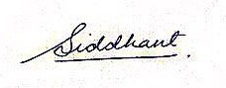

Full Signature of Supervisor Full signature of the student

**AR Inventory Management System**

Raiti Likhit Adarsh

1705349

**Abstract:** Modern day Industry personnel face a challenge in managing their ever increasing inventory and warehouses. We wanted to tackle this problem by using modern day computing and advancements in Augmented Reality. We developed an application that lets the personnel use smartphones to more efficiently organise and document their wares.

**Individual contribution and findings:** I was incharge of the label layout for the app which displays the label over an object. It contains a placeholder textview to put data from the database into.

**Individual contribution to project report preparation:** I documented Ch 1 Introduction and Ch 11 References.

And I collaborated with Sidhant Kumar for Ch 3 SRS

And I collaborated with Prashast Sharma for Ch 6 System Testing

And I collaborated with Tanmay Naidu for Ch 10 Future Scope

**Individual contribution for project presentation and demonstration:** I explained the screenshots for the app, Use Case diagram and code for the label layout.

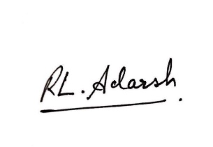

Full Signature of Supervisor Full signature of the student

Plagiarism Report

Plagiarism Checker X

